**Legend***(Ctrl + Click to go to section)*

1. **What does this function do?**
2. **File Structure**
3. **Settings**
4. **How to Run**
5. **Runtime Outputs**
6. **Final Outputs**
7. **Troubleshooting**

**What does this function do?**

**(bulk_sens_spec_optimize)**

This program will create a sensitivity specificity measurement of a set of data. It will compare the sensitivity and specificity of the florescent and 4545 polarization measurement.

To run the function you should have everything included in the file that that you found this function in. These functions are:

blob_diff_circler - This will find a deposit in a single picture after differentiating it and make a circle around it

matching_flor_pol_circle – This takes the circles given by blob_diff_circler from both flor and pol and compares them to see if they are well fit circles

matching_circler_bulk – This will take all the locations and run matching_flor_pol_circle on them and put the results all together

AND inside the basic_functions file should be:

find_file – finds a file based off of basic specifications and gives file and path name

makefile_path – This will create a folder in which data is stored. If a file with that name already exists, it will move and timestamp the file.

**How to Use bulk_sens_spec_optimize.m**

1.Setup File Structure: **back to top**

You must have the files setup as follows: **(I recommend using Bulk Rename Ultility if they are incorrect)**

1st There must be a file named “Raw Data” that all the files sit within.

**NOTE: It is HIGHLY recommended that this sits on your local hard drive (not Y:)**

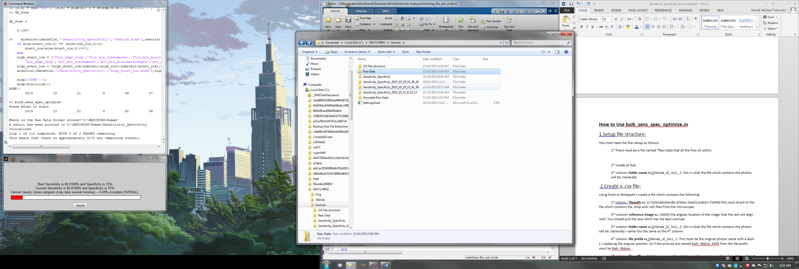

2nd Inside of that should be every location which you wish to analyze

Naming conventions do not matter here, but this is how each location will be denoted in results

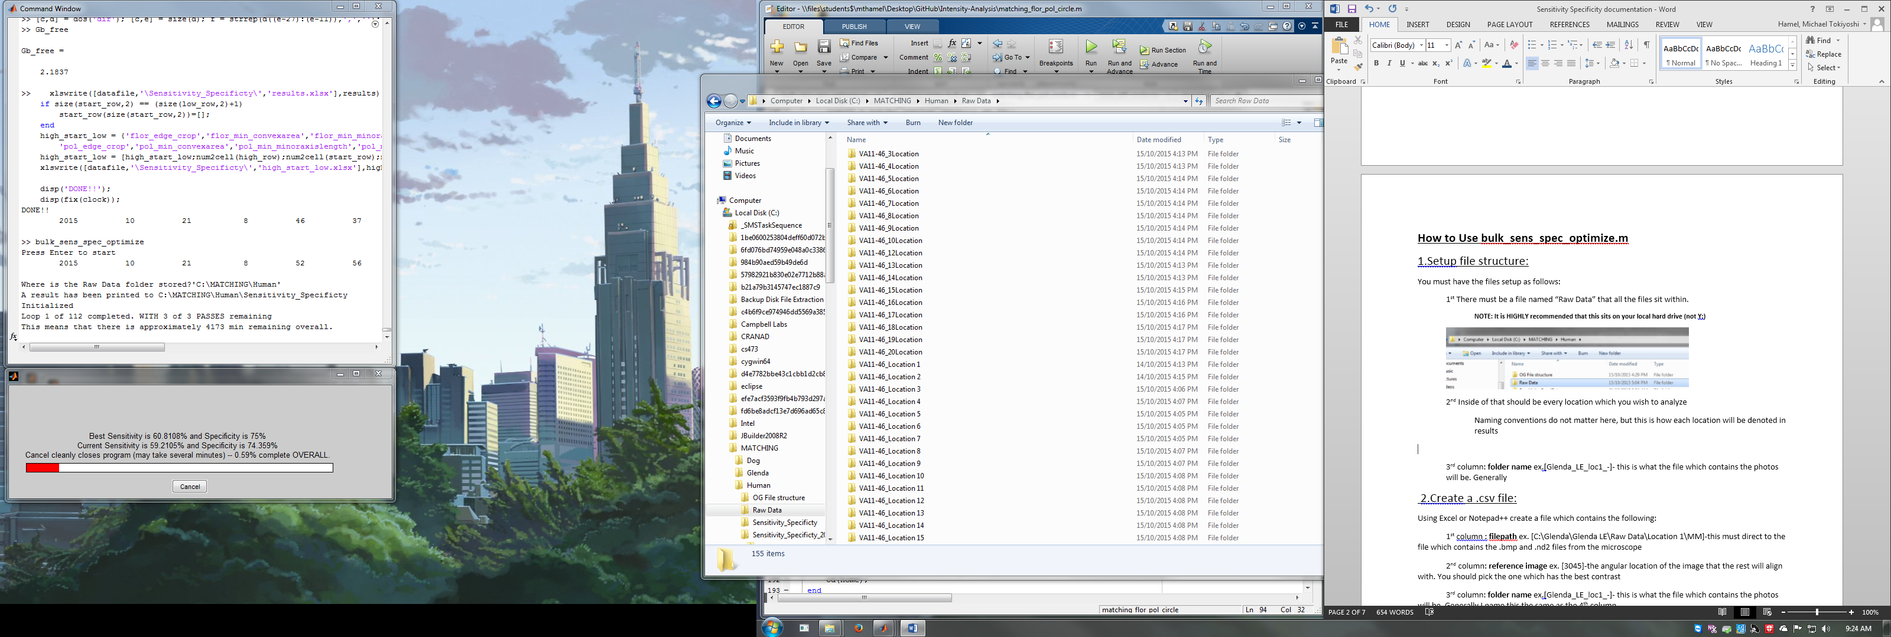

3rd Inside of each location should contain a minimum of two files named F & MM

**NOTE: The files in step 4 can also just sit in this file and it will work**

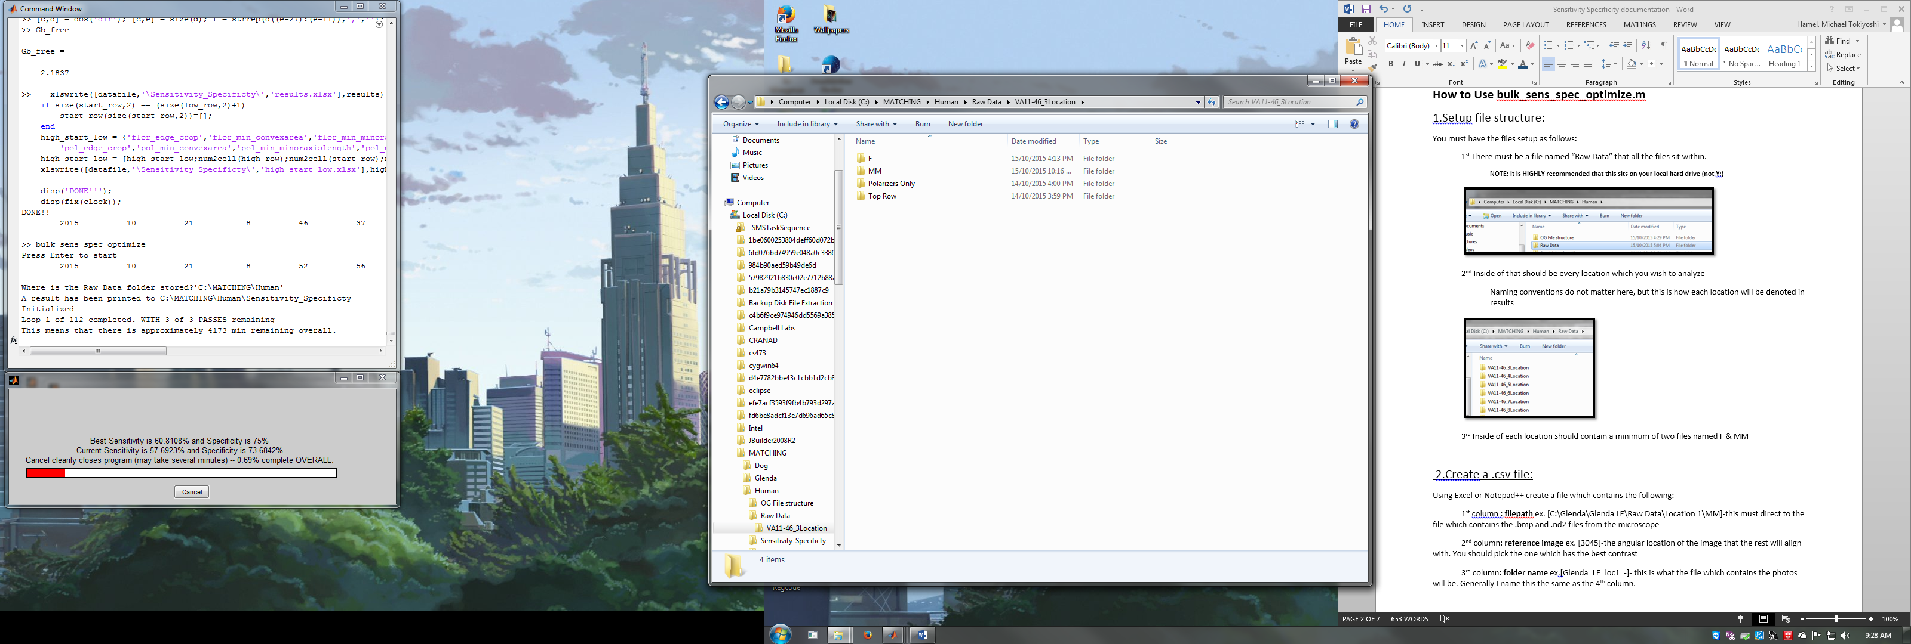

4th Each F and MM require something:

Inside of F- the monochromatic florescent photo with “mono” at the end

Inside of MM – the 4545 polarization photo with “4545” at the end

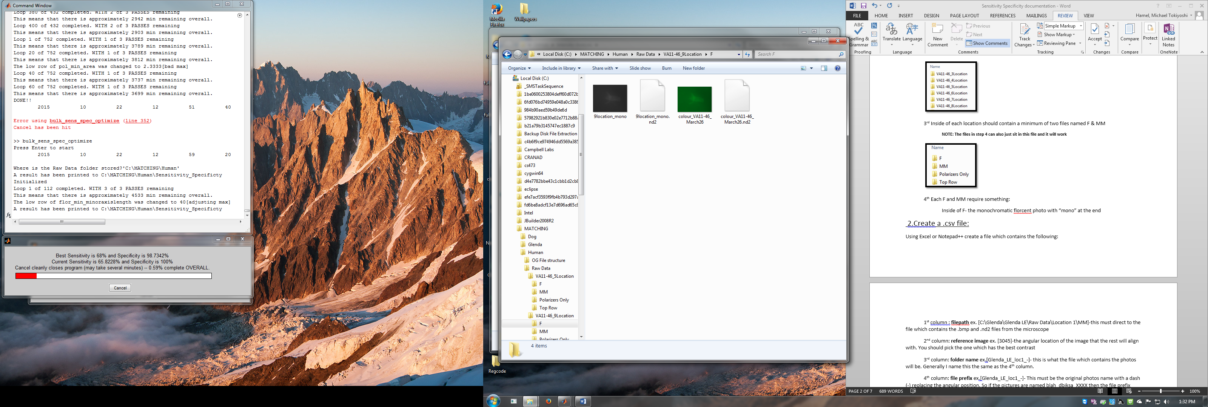  **NOTE: These photos can sit within a folder named bmp as well**

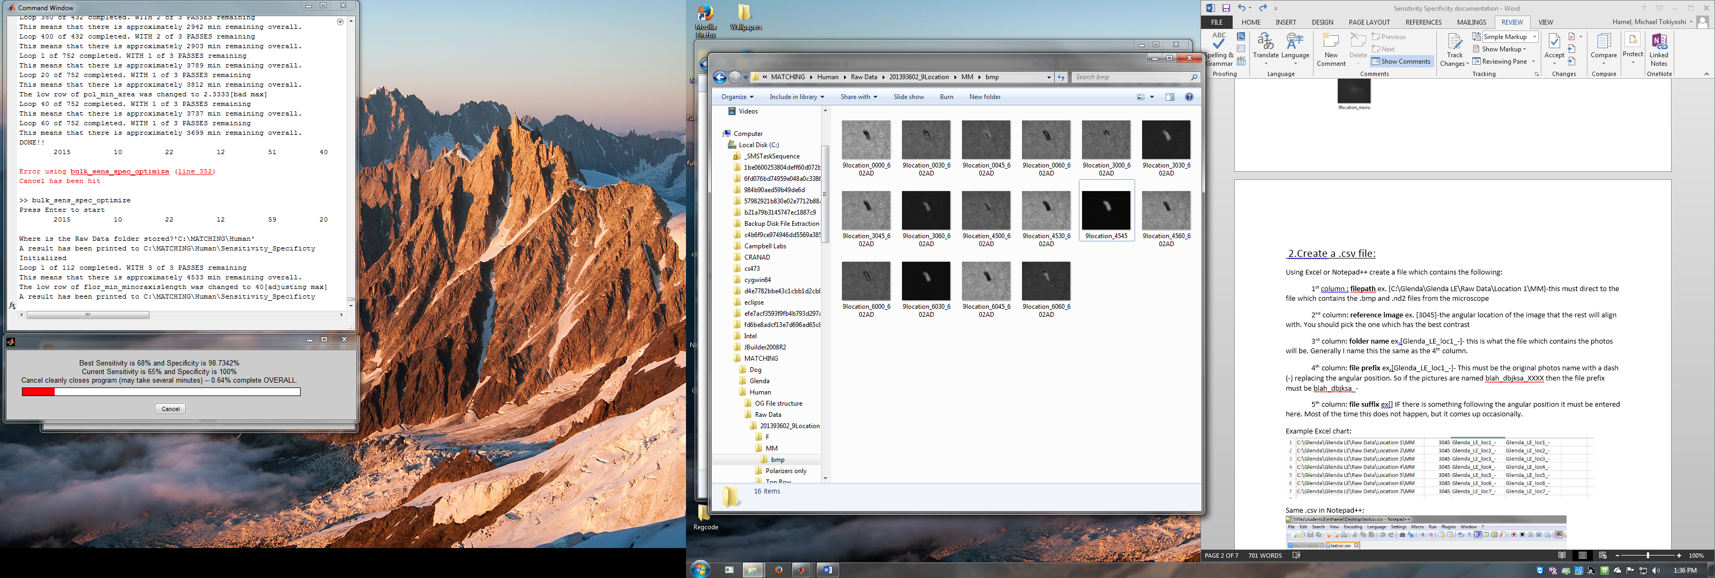

2.Check Settings: **back to top**

Open bulk_sens_spec_optimize.m to see if settings are acceptable.

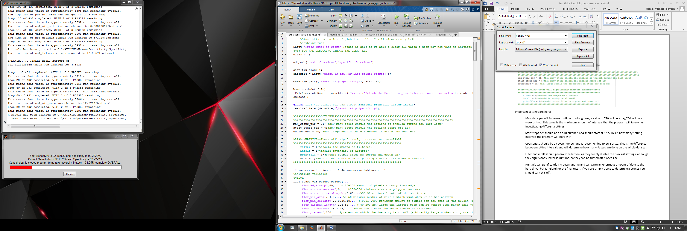

Important settings are here:

Max steps per will increase runtime to a long time, a value of ~20 will be a day,~50 will be a week or two. This value is the maximum amount of intervals that the program will take when investigating different settings **[I personally set it to 50+ and just cancel it if I want to stop the run]**

Start steps per should be an odd number, and should start at 5ish. This is how many setting intervals the program will start with.

Courseness should be an even number and is reccomended to be 4 or 10. This is the difference between setting intervals and will determine how many Passes are done on the whole data set.

Filter and intalt should generally be left on, as they simply disable the two last settings, although they significantly increase runtime, so they can be turned off if needs be.

Print file will significantly increase runtime and will write an enormous amount of data to the hard drive, but is helpful for the final result. If you are simply trying to determine settings you should turn this off.

Show will give displays of a lot more information, and will give more frequent time esitimates .

3.Run Function: **back to top**

Open up bulk_sens_spec_optimize.m and hit Run:

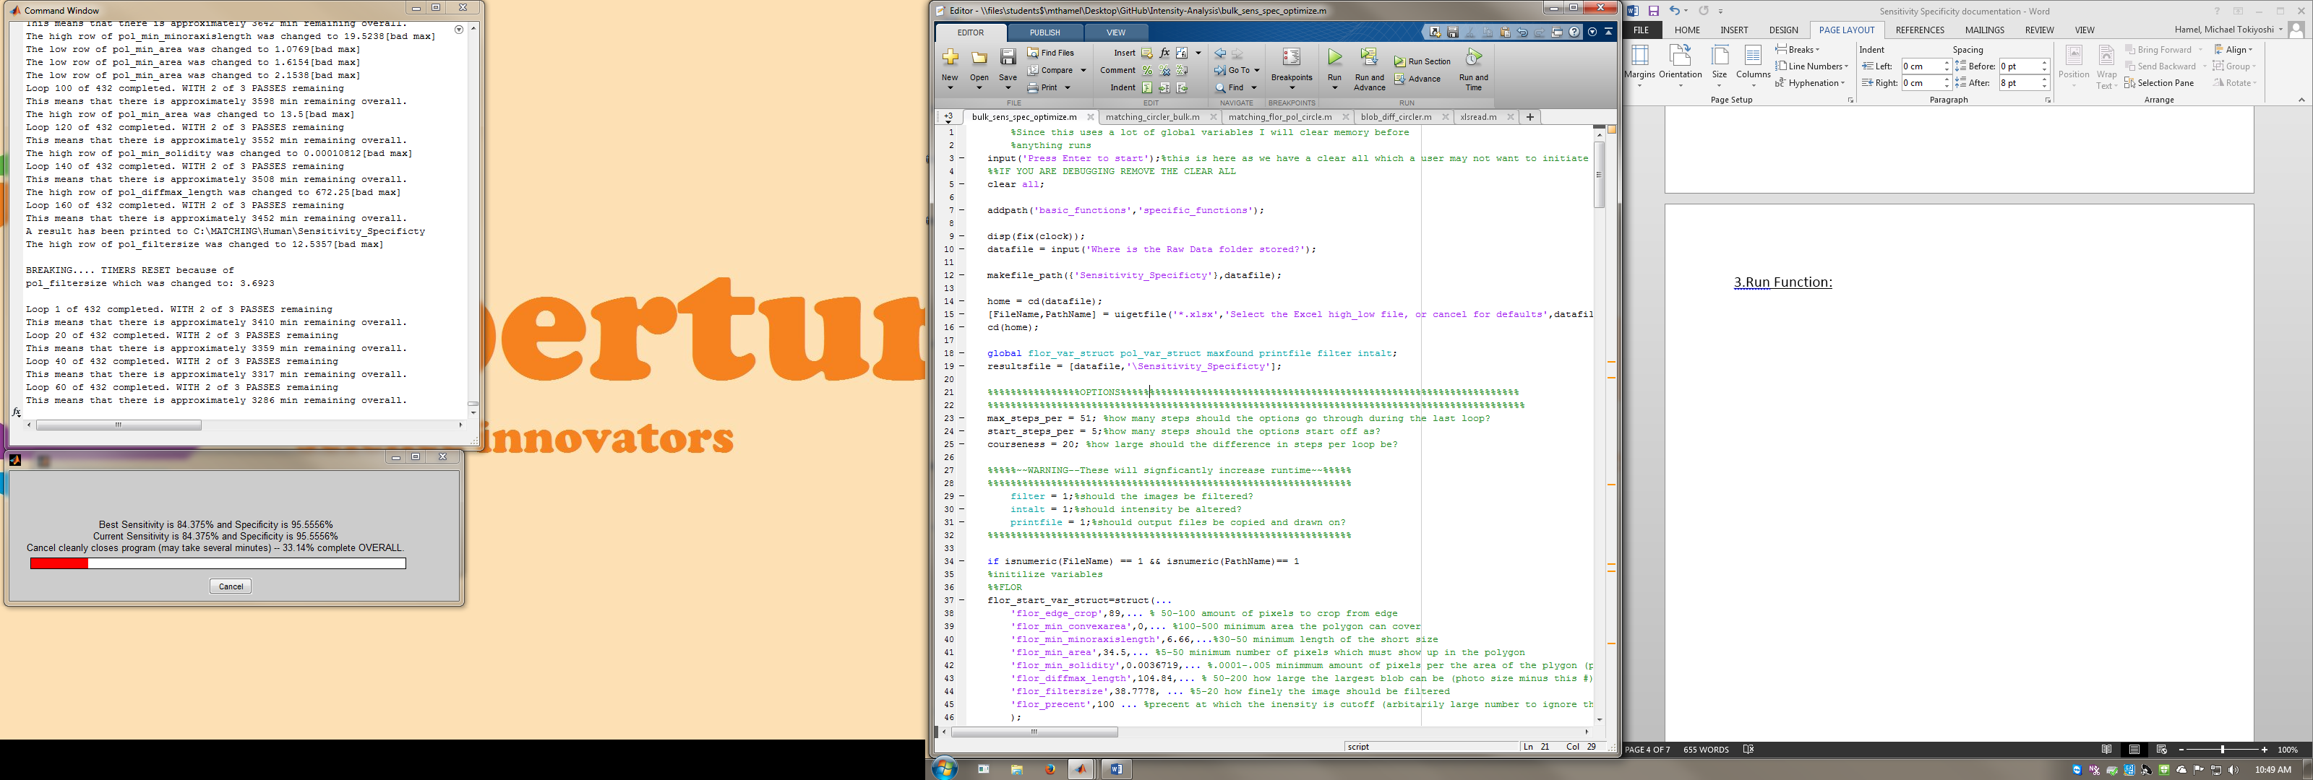

The function will first promt you to hit enter, this is to ensure that you wish to remove all the last runs variables (this can be very helpful if you don’t…)

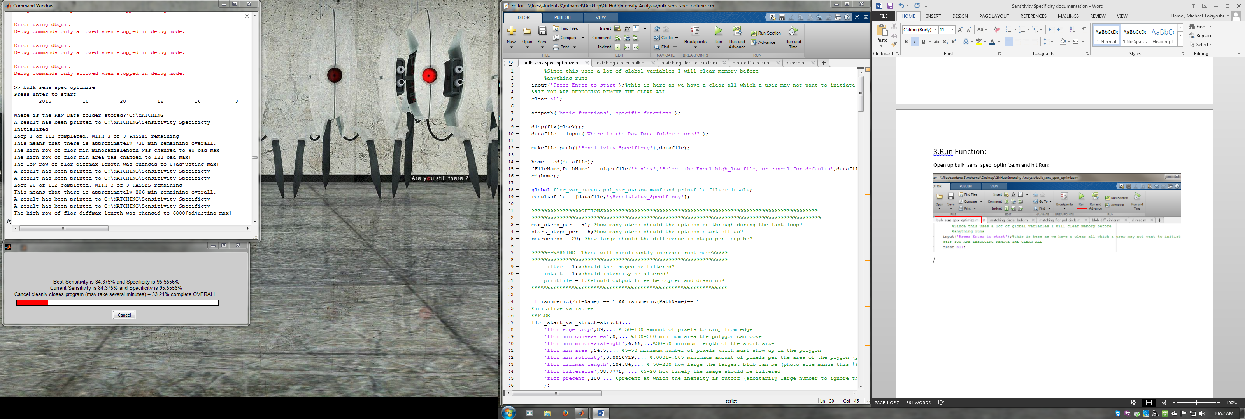

It will then print out the start time and ask you where the file is stored. Simply copy the file adress from the explorer bar, and **add single quotations around it** (it’s a pain to add these in code for some reason)

It will then ask you to pick an Excel file.

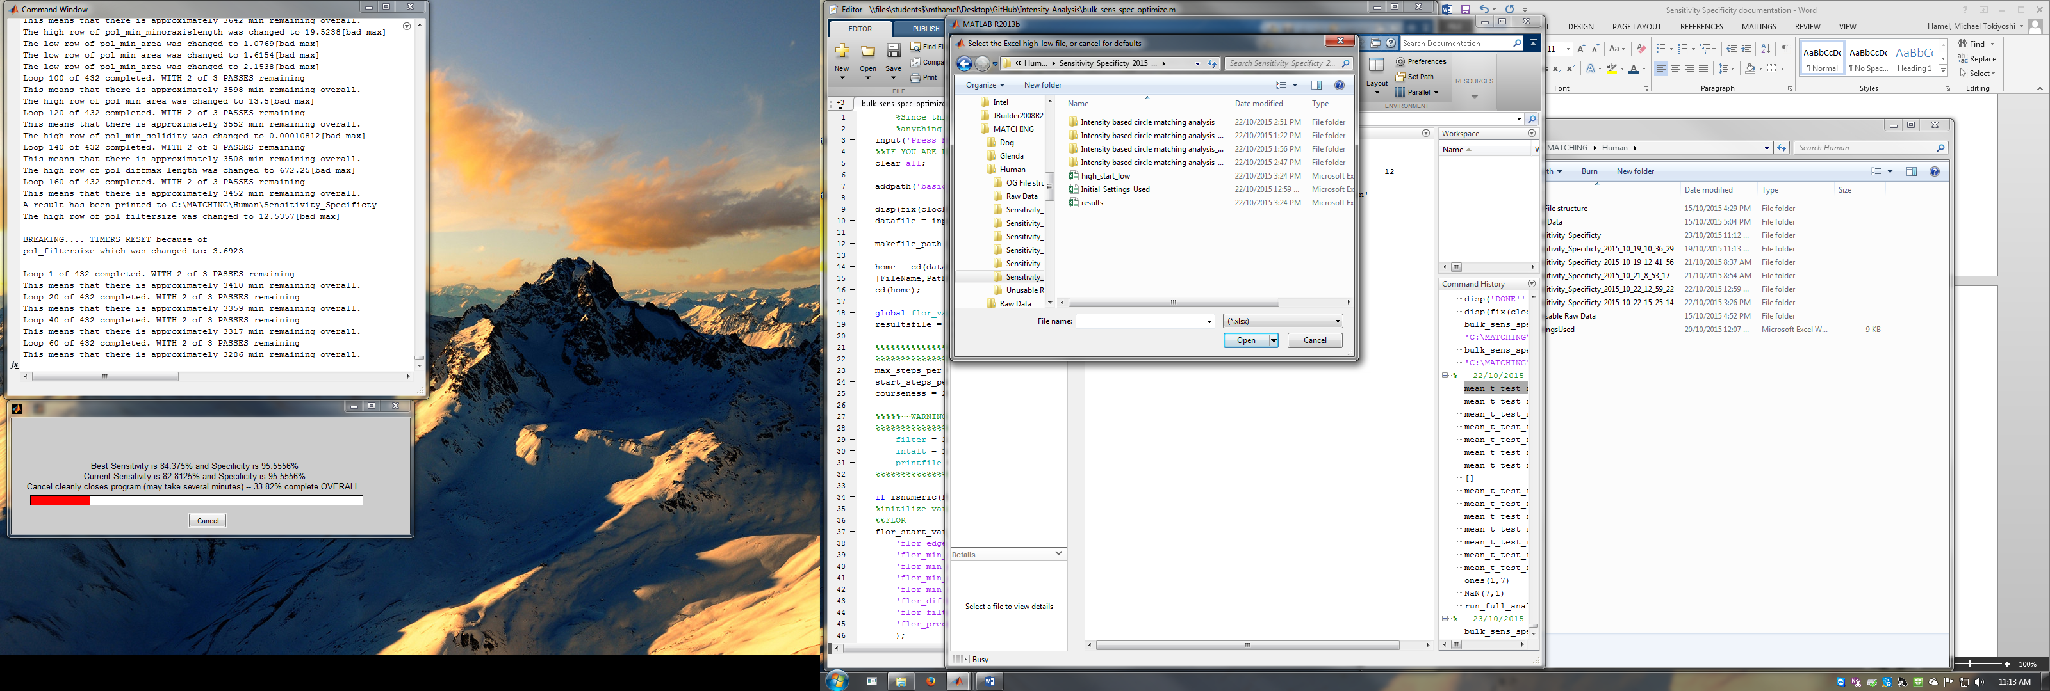This will pick the settings for the function:

You can pick any old run’s high_start_low or Initial Settings used.

**I recommend to pick the newest run of a similar set of data and to run the Initial settings used (or high_start_low)**

If you hit cancel it will simply run the defaults which are set in the function just below the settings I showed before.

**Settings are included in the folder which you found this document in.**

Then it will take quite some time…. And it will give you a dialoge box

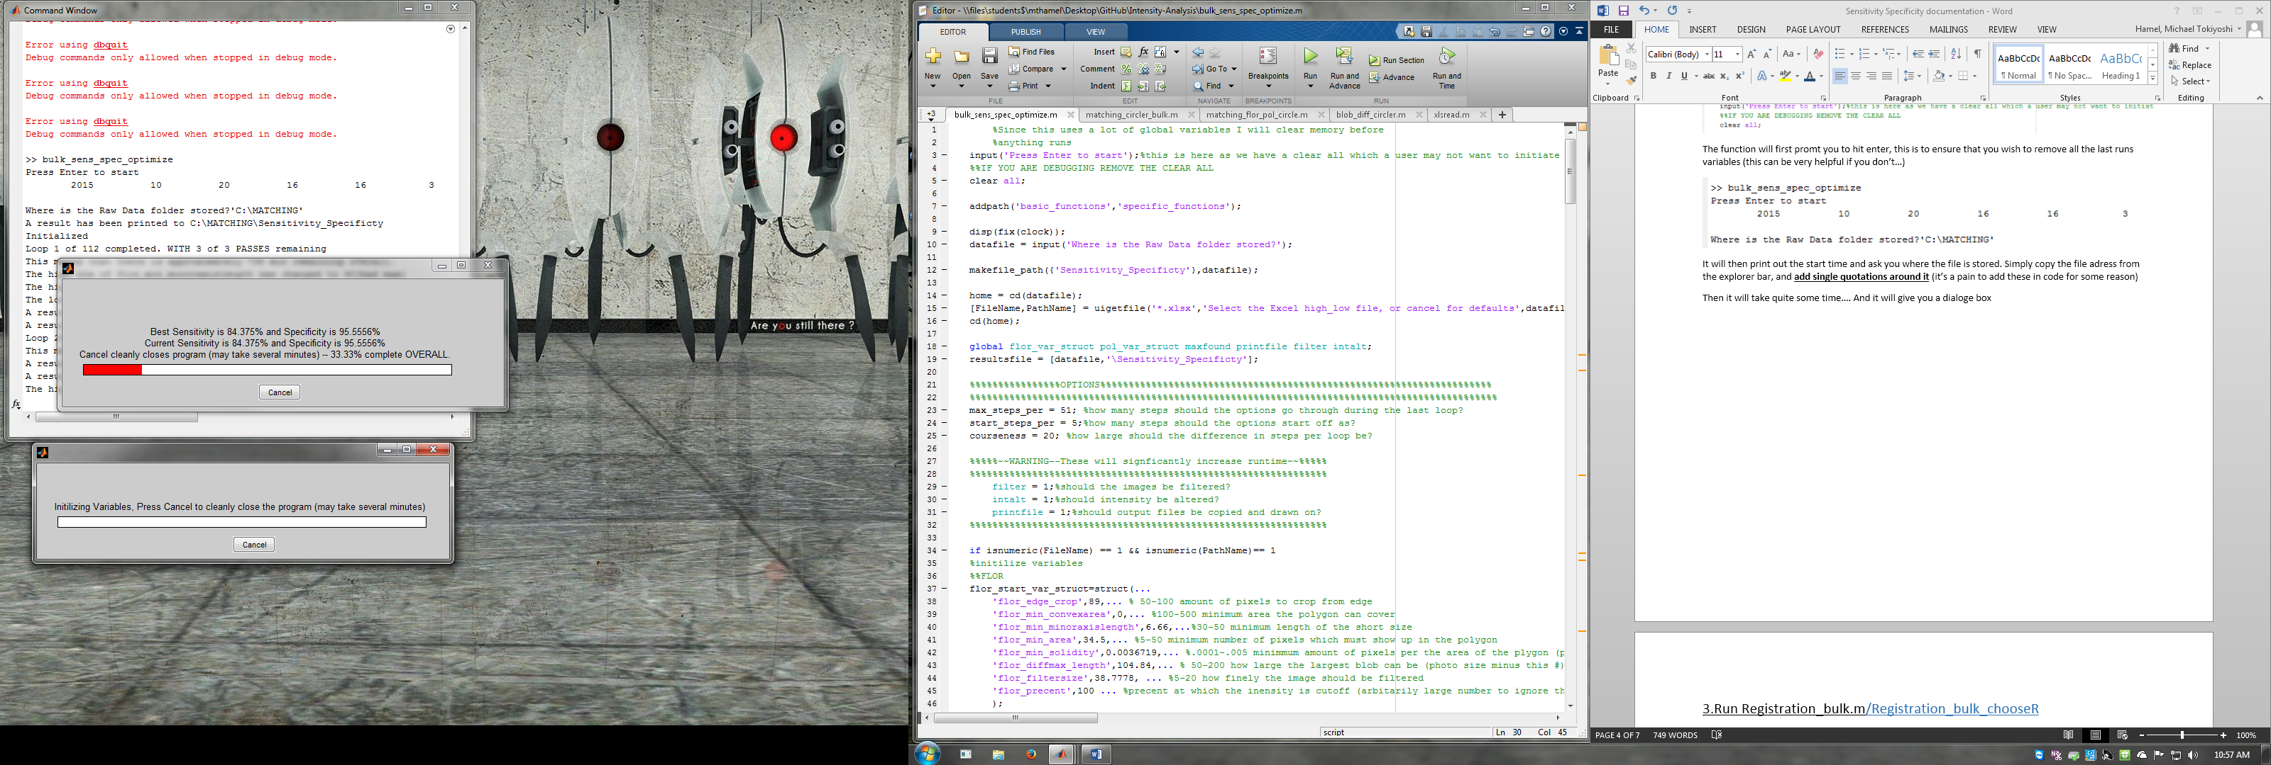

Then the dialoge box will change to :

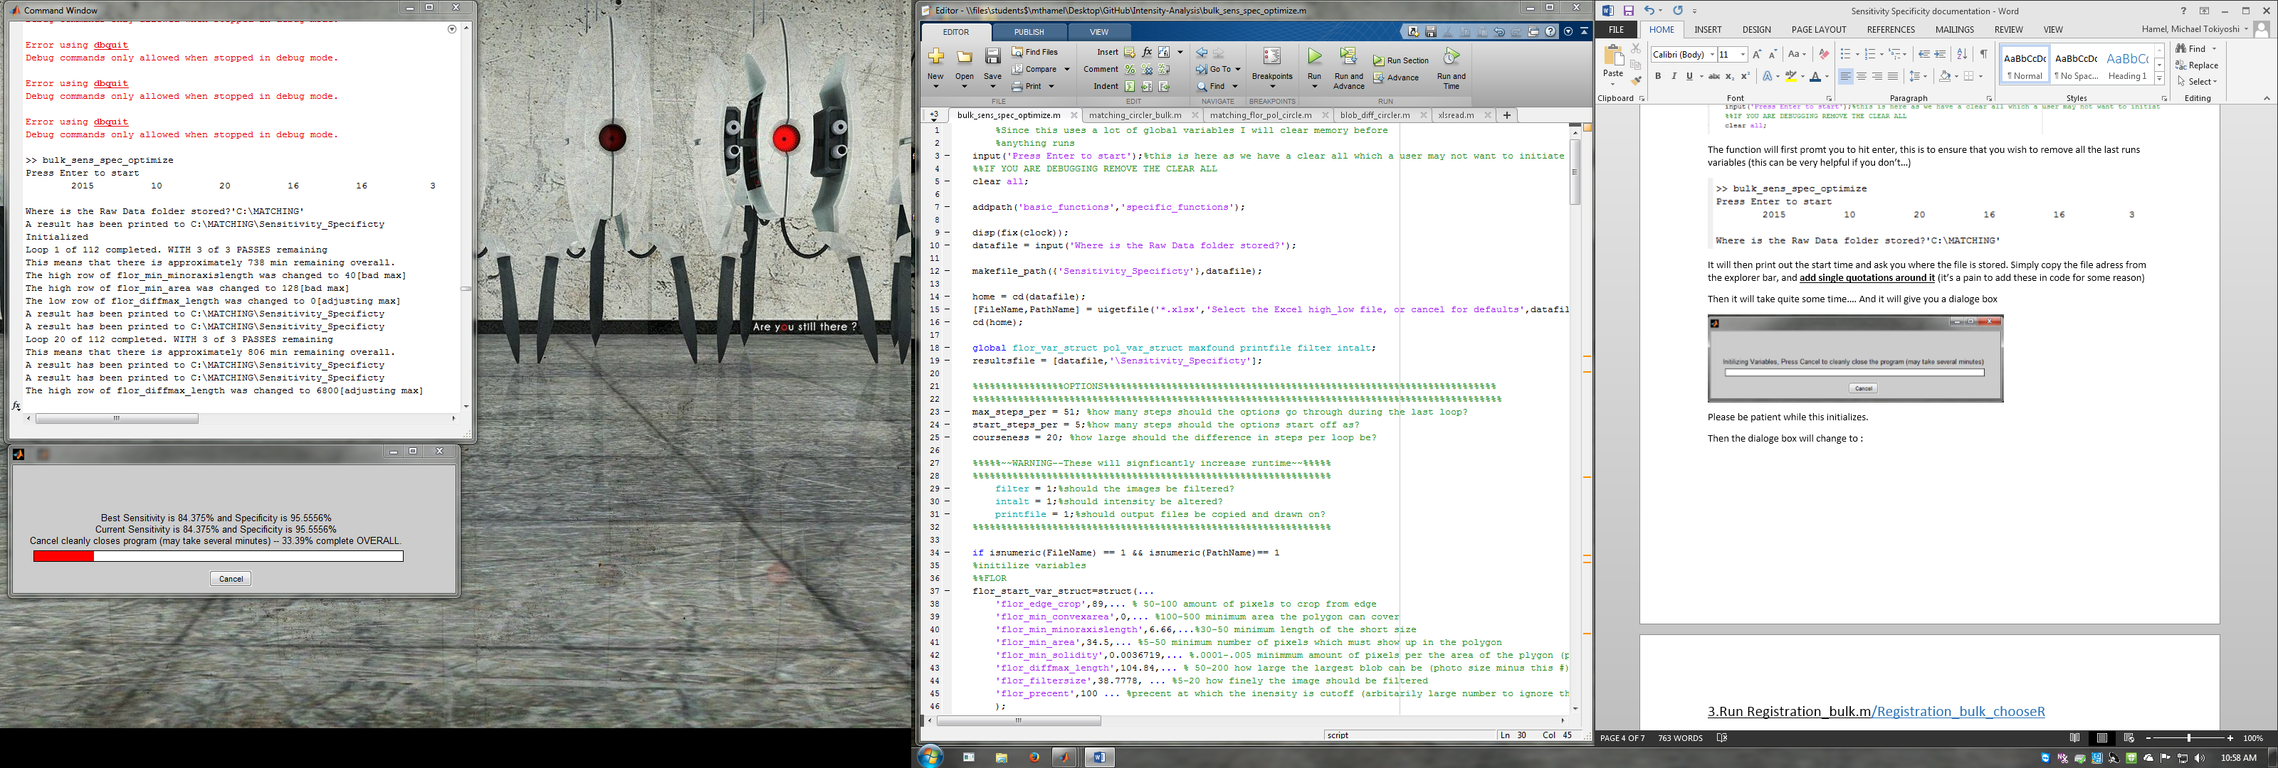

Rezise the box to see all these lines of text (it will lag when you do this, but will eventually update)

Press cancel if you wish to stop the function (will take a couple minutes to cleanly shutdown) and it will give a couple nice output files if you do this.

4.Understanding the Function during Runtime:**back to top**

**If show = 0;**

If you see:

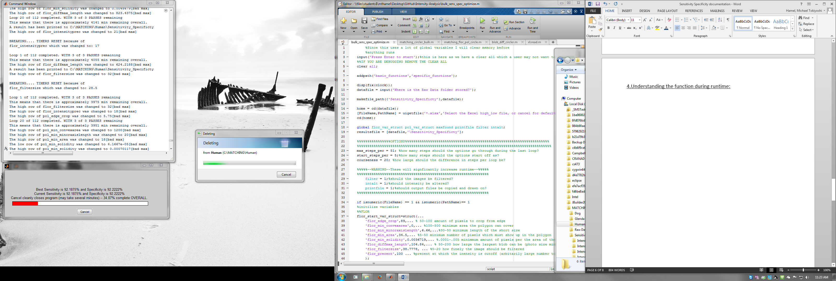

This is a good thing as it means there is a new “best” run and it has printed that result to the file mentioned.

If you see:

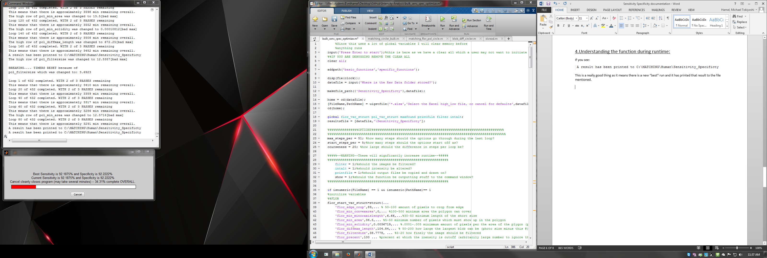

This means a new best setting was found. HURRAY! But it also resets that pass so it will take a fair amount more time. :’(

This prints out every 50 loops and gives a (fairly inaccurate) estimate of the runtime

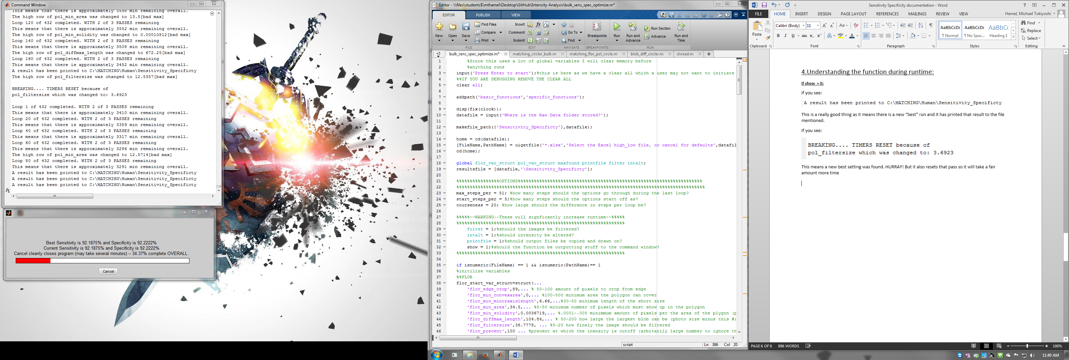

The dialoge box gives a couple pieces of information:

Best Sensitivity and Sepcificity are the best numbers the function has managed to find and it is the set of settings that the function uses as it’s base (where one setting at a time is changed for each run)

Current Sensitivity and Sepcificity is the Sensitivity and Specificity number of the last loop completed: Showing how effective this setting change is.

The completion precentage is the precentage until it is complete for good (hitting max_steps per)

The red progress bar is the precentage of how long it will be until it is finished this settings pass.

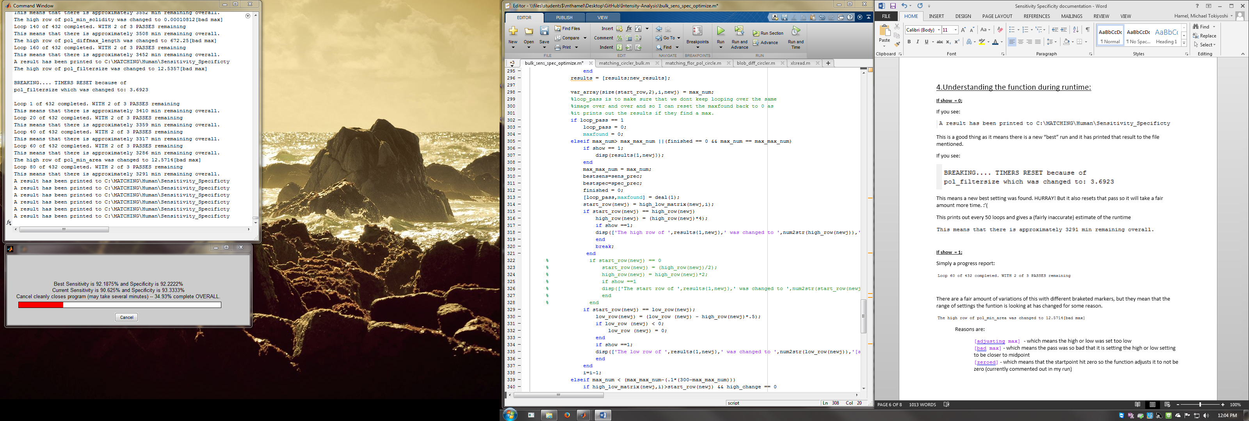

**If show = 1;**

Simply a progress report:

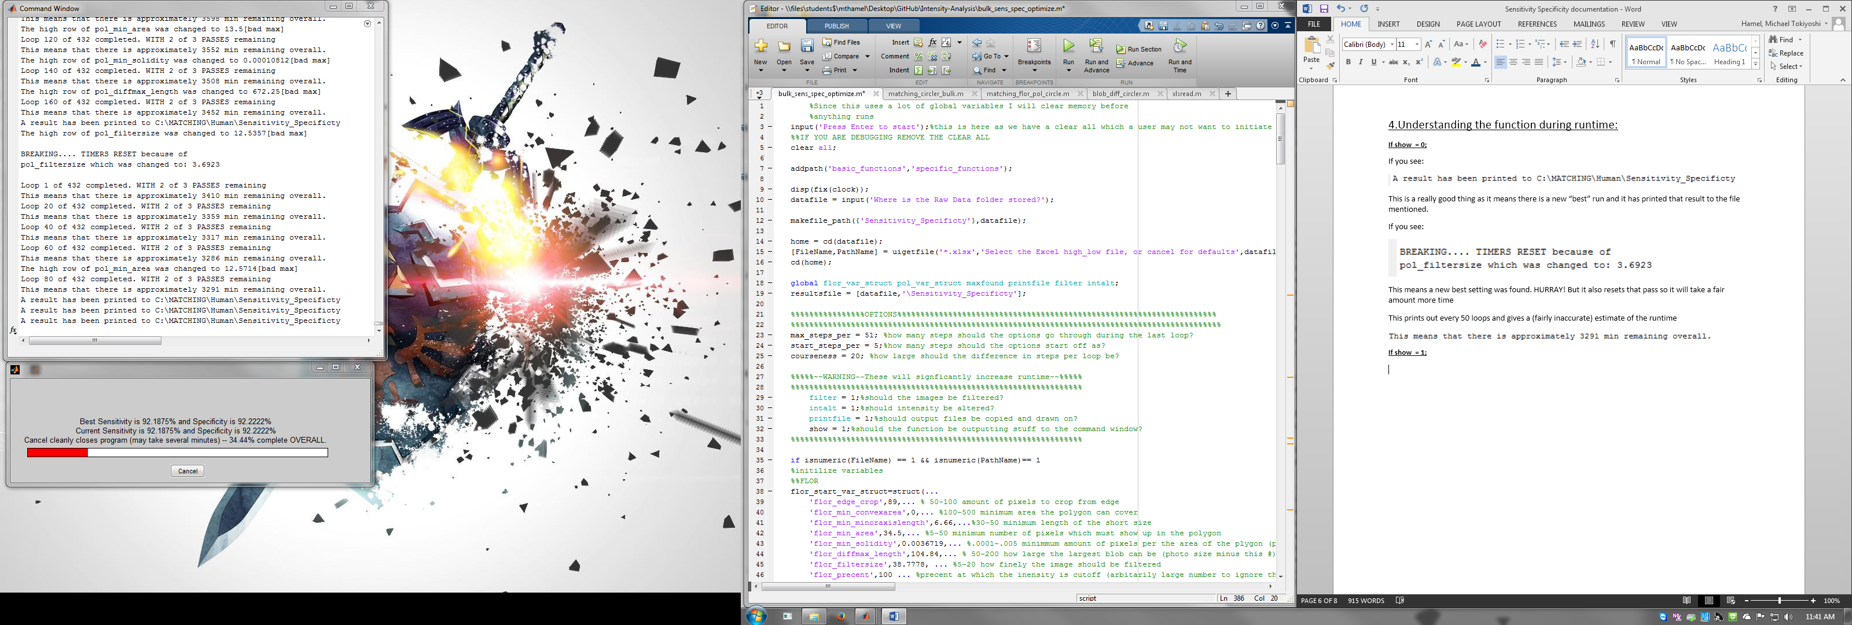

There are a fair amount of variations of this with different braketed markers, but they mean that the range of settings the funtion is looking at has changed for some reason.



Reasons are:

[adjusting max] - which means the high or low was set too low

[bad max] - which means the pass was so bad that it is setting the high or low setting to be closer to midpoint

[zeroed] - which means that the startpoint hit zero so the function adjusts it to not be zero (currently commented out in my run

5. Understanding the Function’s Outputs:**back to top**

This is generally how a final output will appear (once the function has completed running)

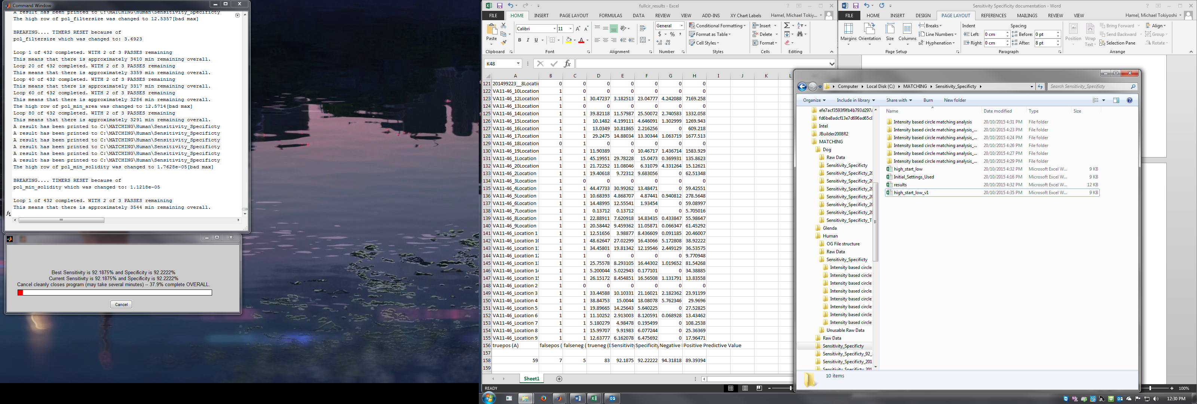

Initial_Settings_Used is the setting file which has been used (either imported or set in code)

The first row is the high setting mark

The middle row is the setting which is initially used

The last row is the low setting mark

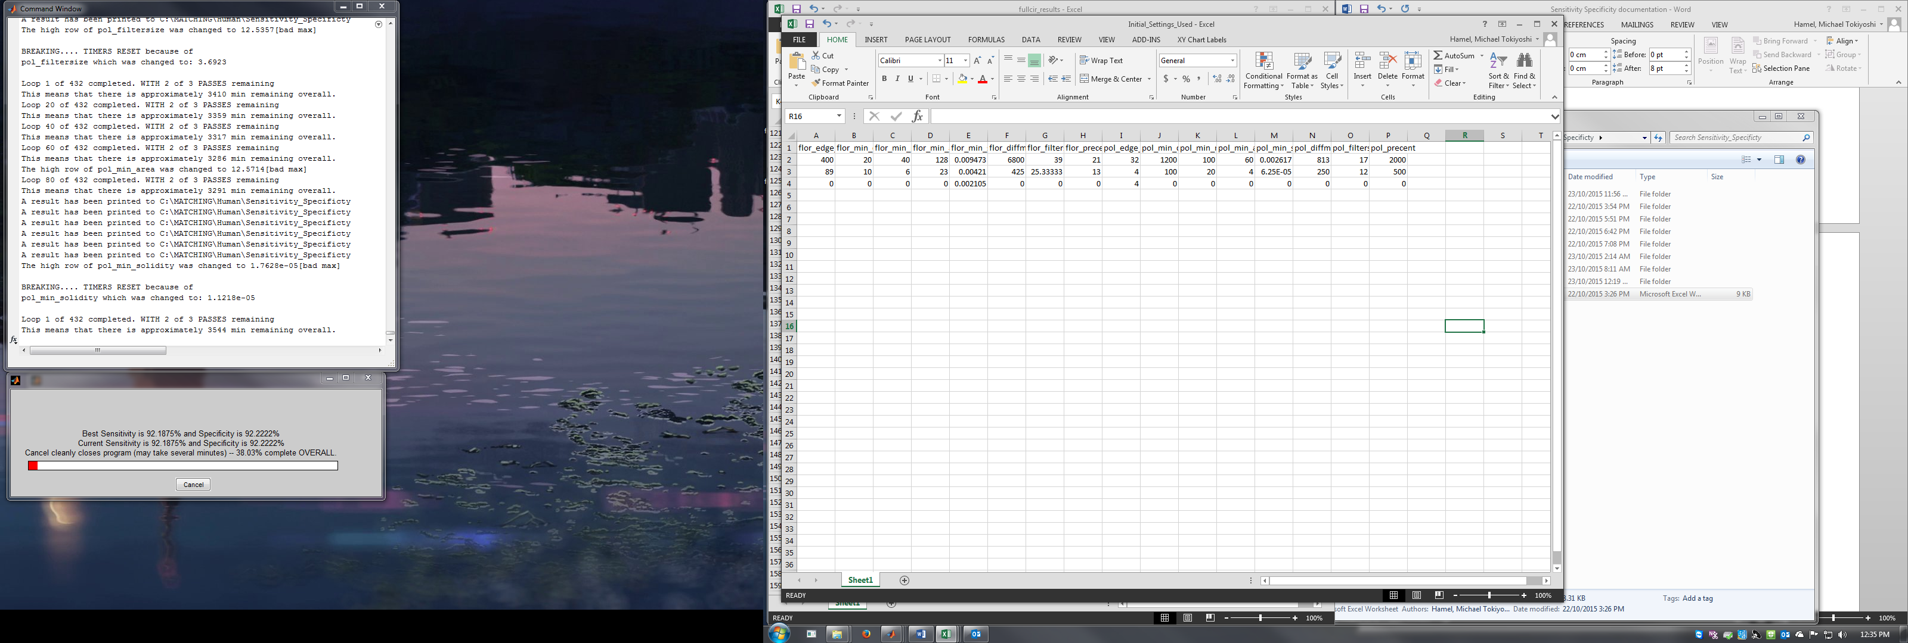

high_start_low is the settings page (setup identically to Intial_Settings_Used) which shows what the function changed these intial variables to be.

------

results (first row pictured , but split is shown below)

Each of the first 16 rows as a separate settings run, with the first coloumns as the setting which was run

max_num is a weighted sum of sensitivity,specificty, negative predictive power and positive predictive power.(this is the number that the program is optimizing for)

true_pos, false_neg, false_pos,true_neg are counts of how many deposists were classified correctly or incorrectly (which sensitivity,specificty,negative predictive power and positive predictive power are calculated off of)

sensitivity,specificty,negative predictive power and positive predictive power are also outputted

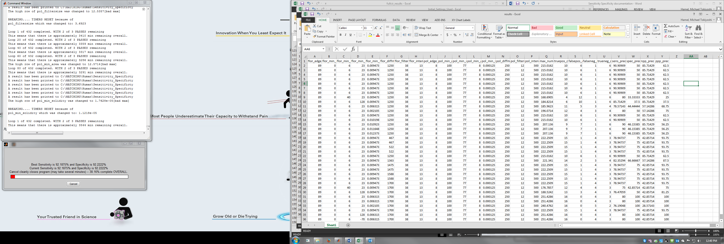



Inside of each Intensity based circle matching analysis file there are a couple results:

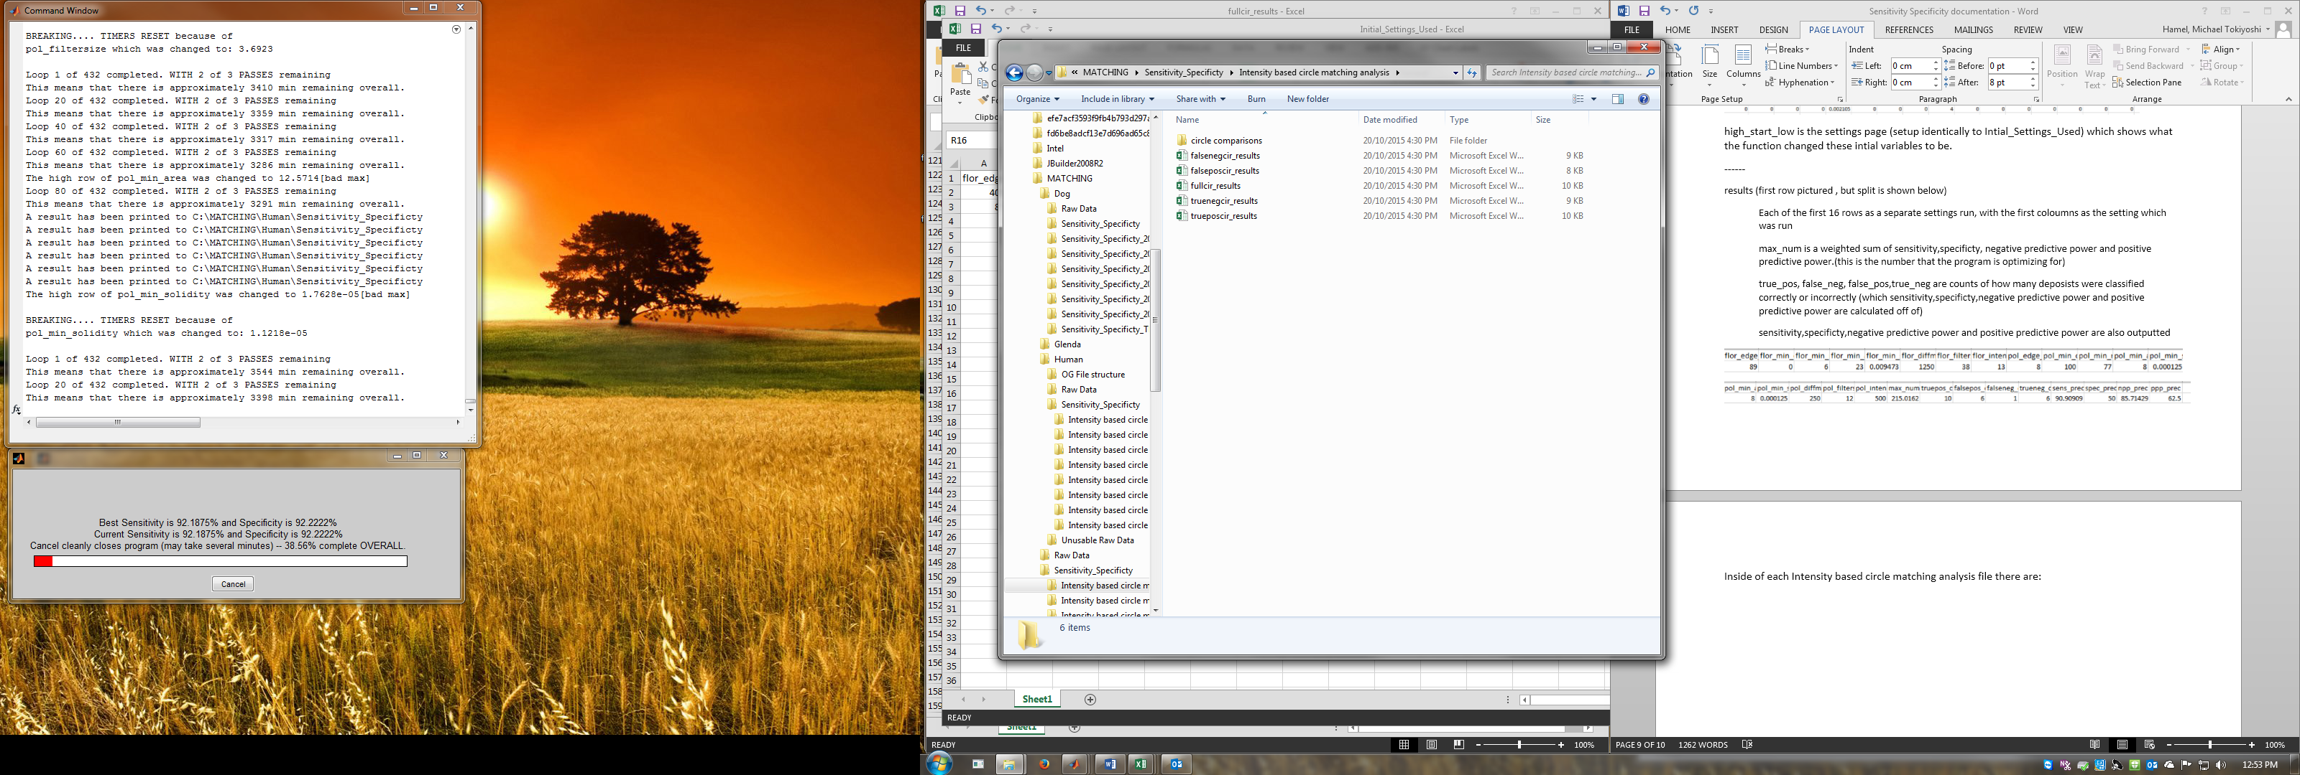

fullcir_results outputs each location and a couple results

The first two columns after the location name is if it finds the location in florecent/polarization as a boolean (0 or 1 for positive/negative)

The next four columns are weither or not the circles overlapped **\*(explained later in the circle comparisons)**

The last column is how large the circles are (as if they are tiny it is possible to have no overlap just because of the size)

The last row gives the numbers of how successful the function was:

truepos, falseneg,falsepos, trueneg are counts of how many deposists were classified correctly or incorrectly (which sensitivity,specificty,negative predictive power and positive predictive power are calculated off of)

Sensitivity,Specificty,Negative Predictive Value and Positive Predictive Value are also outputted

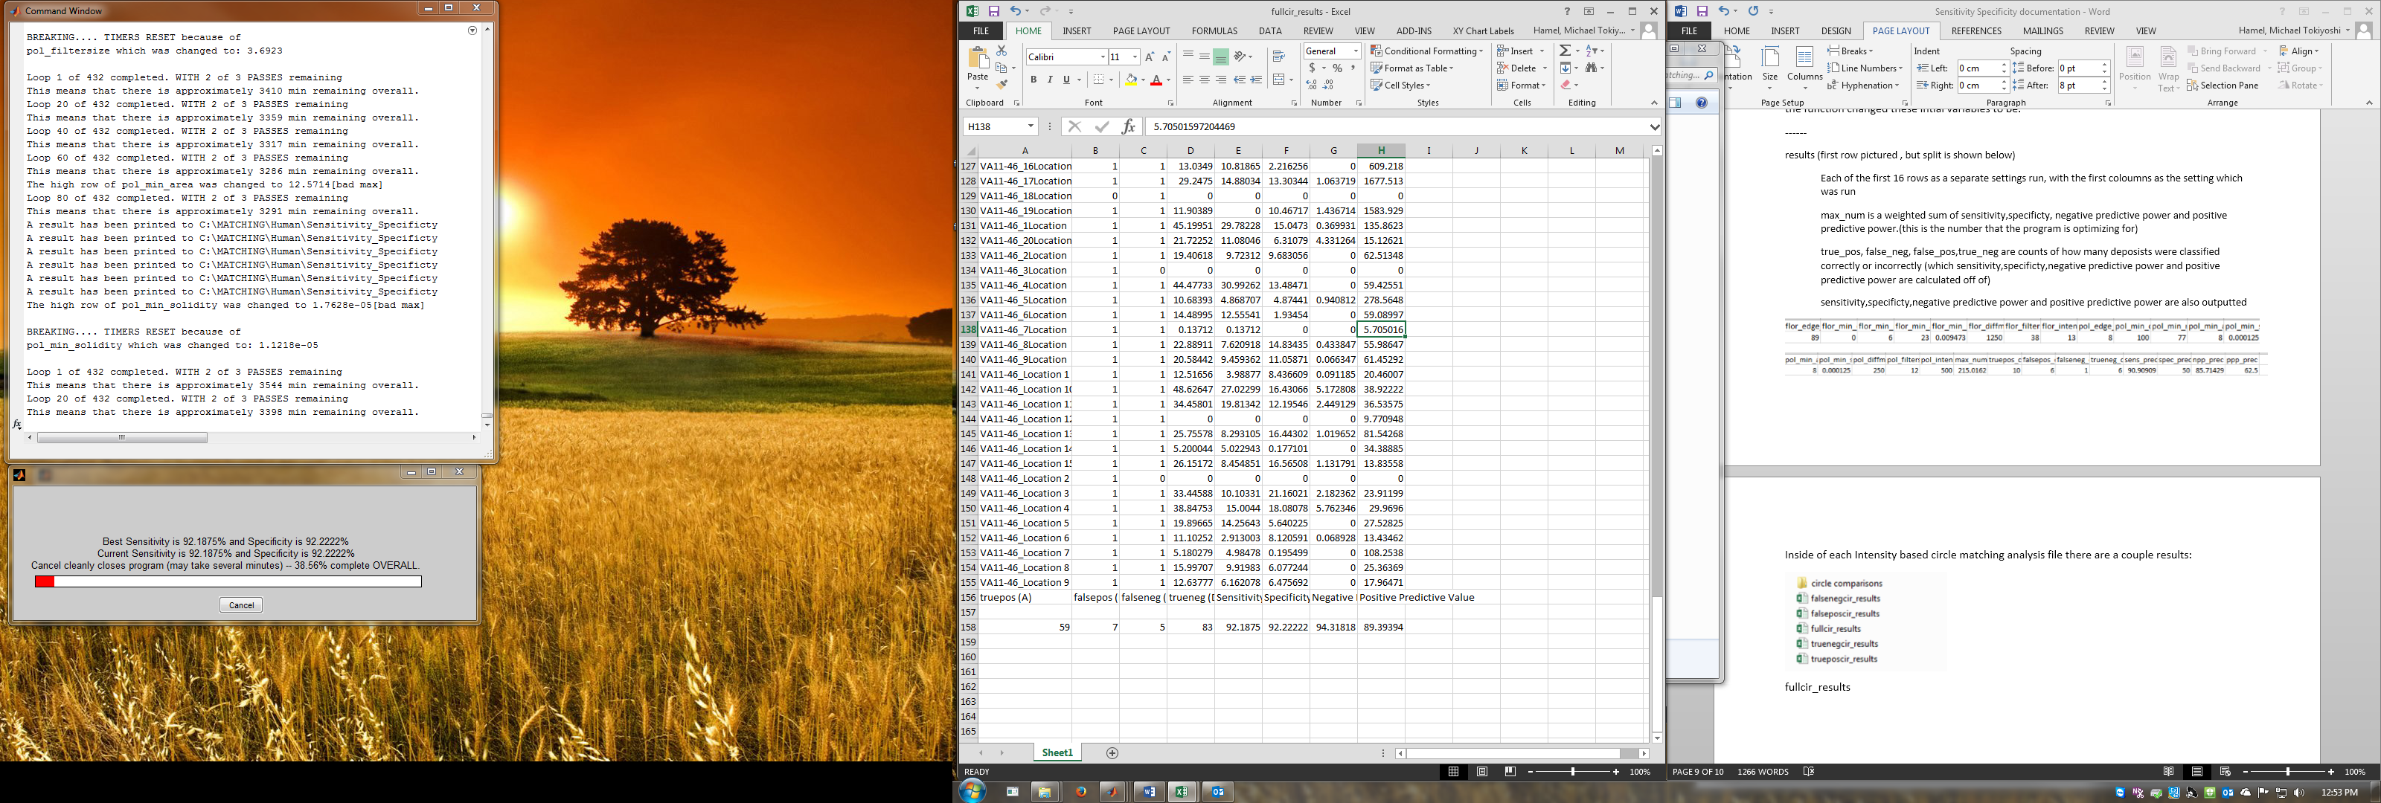

Inside of circle comparisons there will be a file for each deposit:

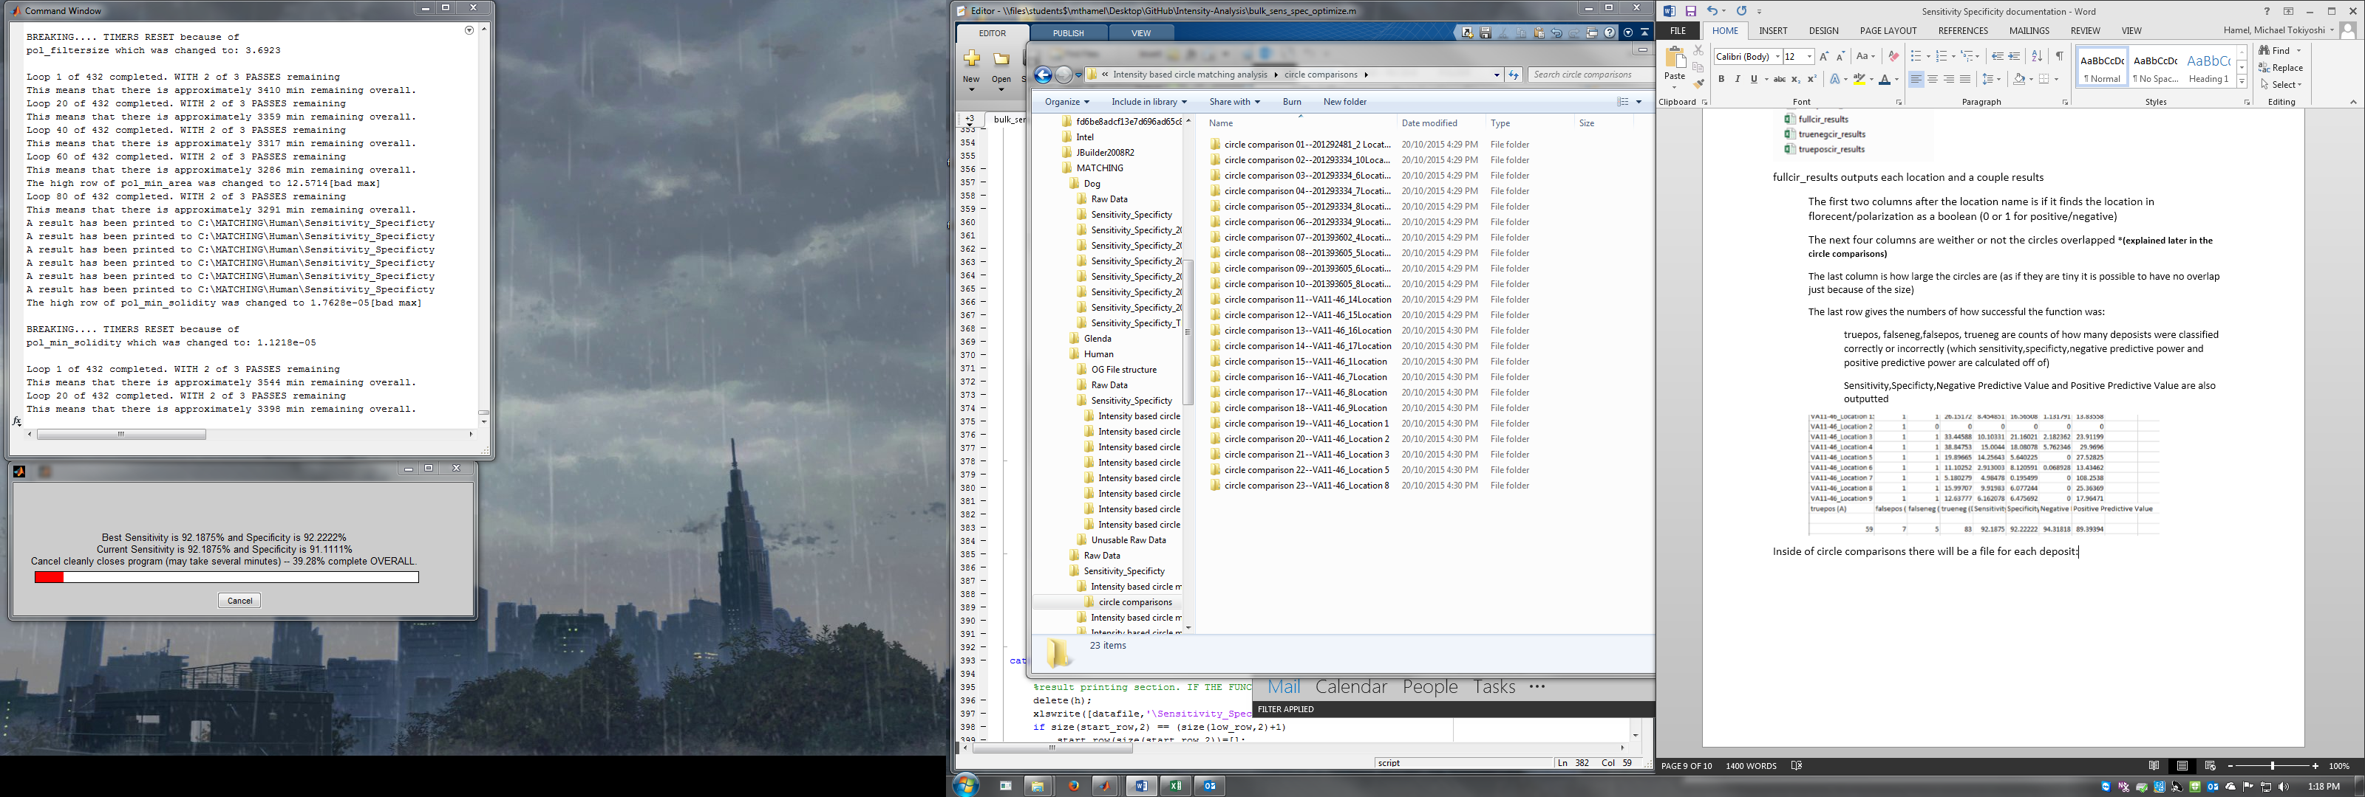

There are two possibilities of how the files inside will look.

If it is a truepos it will output five files:

The first is the overlap image which has the circles which the function draws on each image (as it finds a center and min/max axis for each deposit) and then sees if the circles from each overlap at all.

The second image is a fused image (look up “imfuse matlab” on google for more details)

The third is the fused image with the overlap put on top of it

The fourth and fifth images are just the original images which have been copied over here

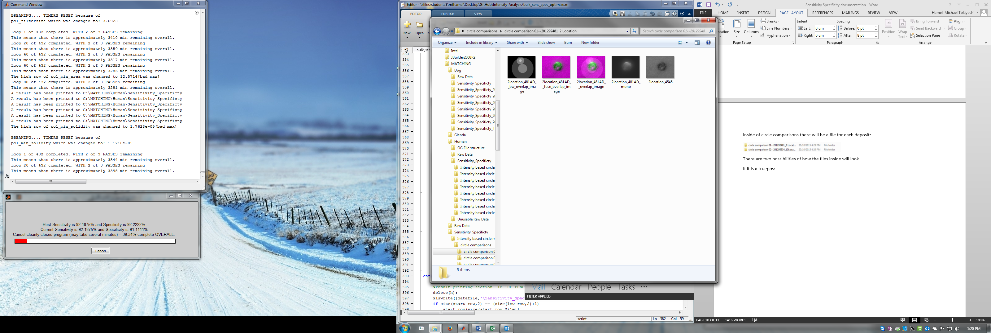

If it is anything but True Pos it will simply output 3 files:

These are the two original images and the fuse image discribed above

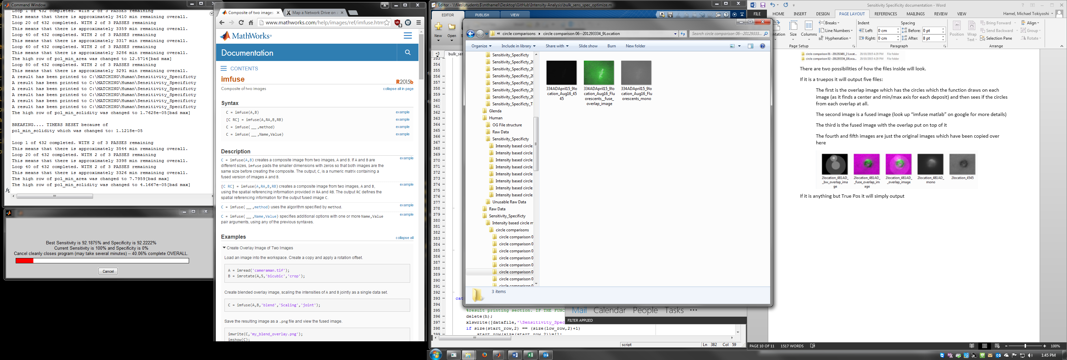

**Troubleshooting** **back to top**

I have split up all the common errors that I have found into the next couple of pages

If you do run into problems I didn’t list feel free to email me at [mthamel@uwaterloo.ca](mailto:mthamel@uwaterloo.ca)

*(Ctrl + Click to go to error)*

**copyfile**

**movefile**

**Cancel**

**matching_flor_pol lines 29-70 (bad file name)**

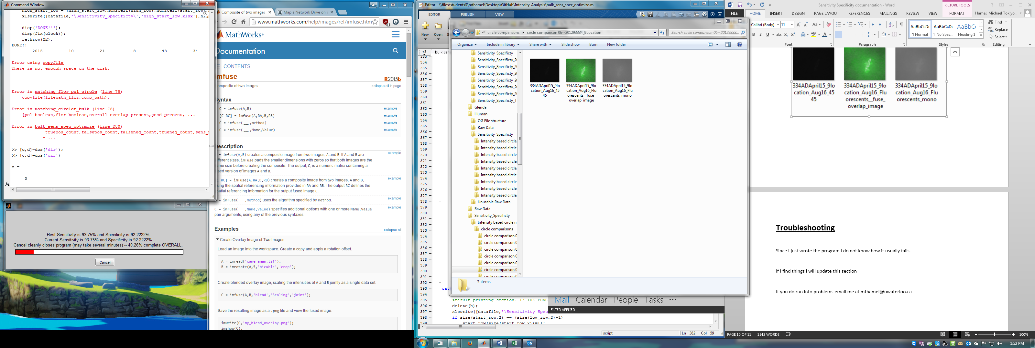

This error is fairly straightforward, but I bring it up to mention that this function can generate tens to hundereds of gigs of data, so it is important to manage this (old Intensity analysis files can usually be deleted without issue)

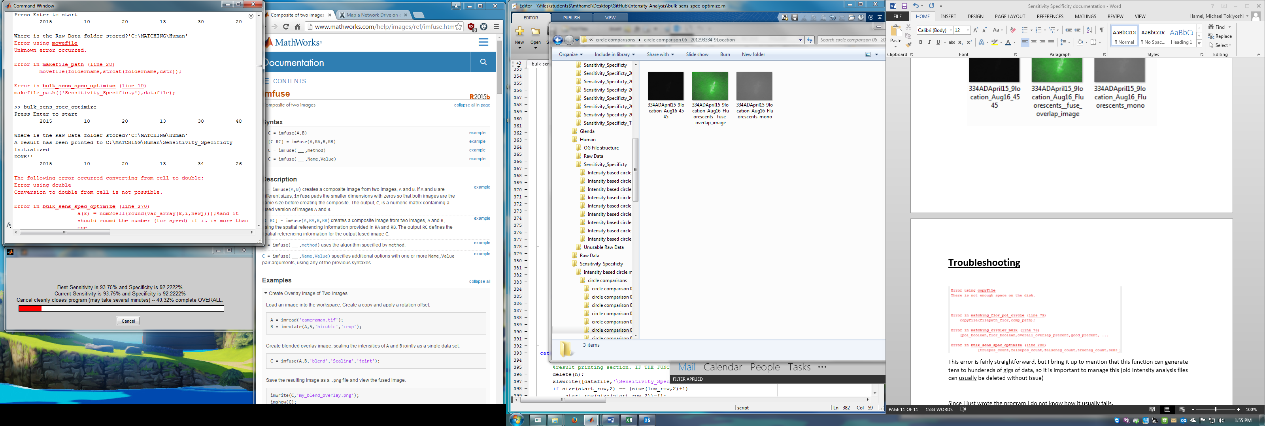

This error generally occurs if you are accessing the a file inside the output while the program is running. To avoid this only access files inside folders which have been timestamped

(ex. Intensity based circle matching analysis_2015_10_22_17_51_25 is okay and Intensity based circle matching analysis is not and should not be accessed until the program says “ DONE!!”

If you are not accessing the file it’s another program doing it. Check if a virus scan is running and that Matlab’s cd is the code file. If nothing is simply retry running the program. If it fails in the same way again restart the pc. If it fails again pour your coffee (or tea) on the couputer, making sure to hit the cpu and harddrive. Then complain to someone about your computer failing and get a new computer. If it fails again after this email me at [mthamel@uwaterloo.ca](mailto:mthamel@uwaterloo.ca).

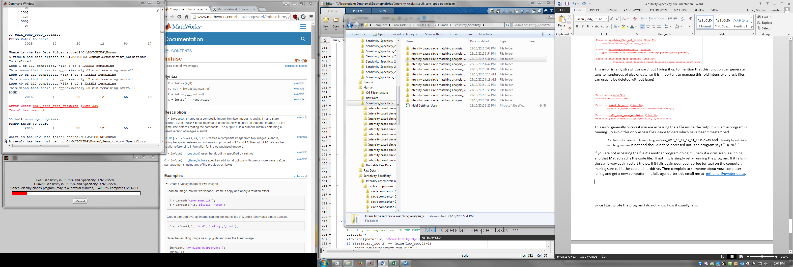

This isnt actually an error, it just means that you hit cancel… If you didn’t do it blame the person closest to you for hitting the button

If it fails on matching_flor_pol_circle from line 29 to 70 or in find_file this means that you didn’t name the file correctly.

If this happens change debugging to 1 and run the program again the function will output which files it is trying to access now. Check the folder before the crash for where the file is not named in accordance with the specifications given in section 1 (Setup File Structure)

